**Sri Guru Hari Singh College, Sri Jiwan Nagar**

**Teacher/Student Feedback Analysis 2019-20**

Forms response chart. Question title: The Programme Outcome and Course Outcomes are well defined.
. Number of responses: 10 responses.Forms response chart. Question title: Sufficient number of relevant reading material / books /reference books and digital resources are available in Library.
. Number of responses: 10 responses.Forms response chart. Question title: The course has good balance between theory and application.
. Number of responses: 10 responses.Forms response chart. Question title: Syllabus of this course has increased my knowledge and perspective in subject.
. Number of responses: 10 responses.Forms response chart. Question title: I have freedom to Propose, suggest and incorporate new topics in the syllabus through proper forum.
. Number of responses: 10 responses.

Forms response chart. Question title: I relate the course material to real world situations.
. Number of responses: 10 responses.

Forms response chart. Question title: I have freedom to adopt new techniques/ education tools/ strategies in teaching methodology.
. Number of responses: 10 responses.Forms response chart. Question title: Curriculum and Syllabus are need based.
. Number of responses: 10 responses.

Forms response chart. Question title: I take sufficient steps to provide help and assistance to slow learner/students with special needs.
. Number of responses: 10 responses.

Forms response chart. Question title: I have contributed to the curriculum and/or syllabus development.
. Number of responses: 10 responses.

Forms response chart. Question title: I have freedom to take the students to field visit, experimental learning, etc.
. Number of responses: 10 responses.

Forms response chart. Question title: I use latest ICT tools like projectors,YouTube channels,PPT etc. or providing course material.
. Number of responses: 10 responses.

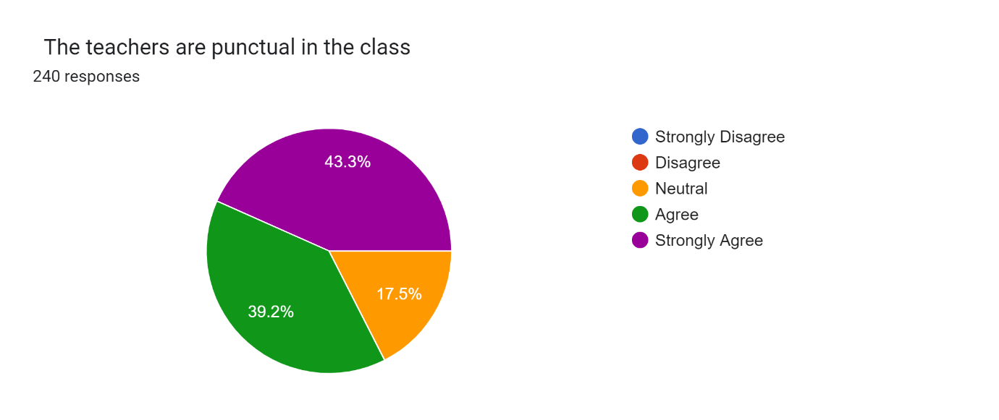

Forms response chart. Question title:   The teachers are regular in the class   
. Number of responses: 240 responses.

Forms response chart. Question title:   The teachers come well prepared for the class  
. Number of responses: 240 responses.

Forms response chart. Question title:   The teachers are able to maintain discipline in the class   
. Number of responses: 240 responses.

Forms response chart. Question title:   The teachers communicate clearly and inspires us   
. Number of responses: 240 responses.

Forms response chart. Question title:   The teachers use innovative techniques in teaching.   
. Number of responses: 240 responses.

Forms response chart. Question title:   The teachers encourage participative learning in the class  
. Number of responses: 240 responses.

Forms response chart. Question title:   The subject content is delivered through adequate examples   
. Number of responses: 240 responses.

Forms response chart. Question title:   Doubt clearing sessions are taken up by the teachers 
. Number of responses: 240 responses.

Forms response chart. Question title:   The teachers complete the entire syllabus  
. Number of responses: 240 responses.

Forms response chart. Question title:   The teachers discuss course outcome in the class   
. Number of responses: 240 responses.

Forms response chart. Question title:   Regular and timely feedback is given after each test  
. Number of responses: 240 responses.

Forms response chart. Question title:   The evaluation process is fair and unbiased   
. Number of responses: 240 responses.

Forms response chart. Question title:   Comfort with online classes   
. Number of responses: 240 responses.

Forms response chart. Question title:   Comfort with online classes   
. Number of responses: 240 responses.

Forms response chart. Question title:   The classrooms are clean and well maintained   
. Number of responses: 240 responses.

Forms response chart. Question title:   The labs are well maintained and equipments are in working condition   
. Number of responses: 240 responses.

Forms response chart. Question title:   The campus has adequate power supply   
. Number of responses: 240 responses.

Forms response chart. Question title:   The prescribed books and reading material are available in the library   
. Number of responses: 240 responses.

Forms response chart. Question title:   Common room with all amenities is available in the college premises  
. Number of responses: 240 responses.

Forms response chart. Question title:   Reading space in the library is available  
. Number of responses: 240 responses.

Forms response chart. Question title:   The library staff is cooperative and helpful   
. Number of responses: 240 responses.

Forms response chart. Question title:   Internet facility is available in the college   
. Number of responses: 240 responses.

Forms response chart. Question title:   Photocopy facility is available in the college   
. Number of responses: 240 responses.

Forms response chart. Question title:   The administrative staff is helpful  
. Number of responses: 240 responses.

Forms response chart. Question title:   Results and attendance records are discussed   
. Number of responses: 240 responses.

Forms response chart. Question title:   Toilets/washrooms are hygienic and properly maintained  
. Number of responses: 240 responses.

Forms response chart. Question title:   Clean drinking water is available in the campus  
. Number of responses: 240 responses.

Forms response chart. Question title:   Grievances/problems are redressed well in time  
. Number of responses: 240 responses.